Covid-19 Dialog Flow Chatbot

Artificial Intelligence

Project Report 2021

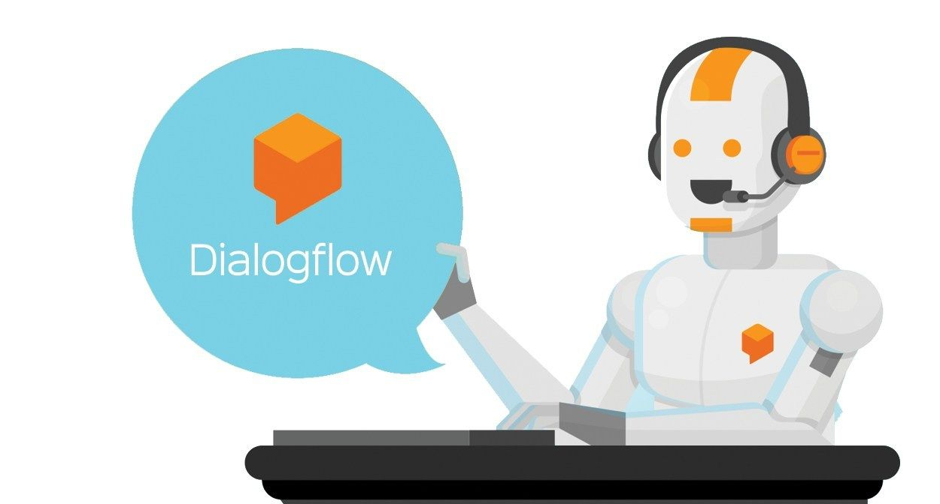

Group Members: Class id: 106266

* Muhammad Sheroz 9852
* Kehkashan Akram 9825

Content:

1. Introduction to problem
   1. Introduction
   2. Description
      1. What is ChatBot?
      2. What is DialogFlow?
   3. Software Requirements
2. Project Planing
   1. Expected Result
   2. Code Language
   3. GitHub Link
   4. Project Planning
3. Progress Table
4. Basic ChatBot Flow
5. DialogFlow
   1. Intent
      1. Welcome intent
   2. Entities
   3. Knowledge Base
   4. Covid-19 FAQs
   5. Fulfilment
   6. Integration
6. Heroku
   1. Deployment Log
   2. Build Log
7. Rapid API
8. MongoDB
   1. Cluster
   2. Network Access
   3. DataBase Access
   4. Covid-19 Chat Record Collection
9. GitHub
   1. Repository
   2. Commit Log
10. Code
    1. Code File directory
    2. Requriments
    3. Runtime
    4. Procfile
    5. App.py
    6. Make API Request
    7. Result
    8. Templete Reaader
    9. Test Mongo
    10. Email
    11. MainFest
    12. Graphs
    13. Conversation
11. Creating ChatBot
12. Output of our Project
13. Conculusion

1.0. Introduction to problem

1.1. Introduction:

In this project we creating chatbot dialog flow. It is artificial intelligent awareness system about Covid-19. One can ask questions about covid-19 and it will answer.

* 1. Description:

We are building a chatbot that will give its users awareness about covid-19.

* + 1. What is a Chatbot?

Interacts through instant messaging, artificially replicating the patterns of human interactions.

* + 1. What is dialog flow?

Dialog flow is a natural language understanding platform used to design and integrate a conversational user interface into mobile apps, web applications, devices, bots, interactive voice response systems and related uses.

GitHub Picture

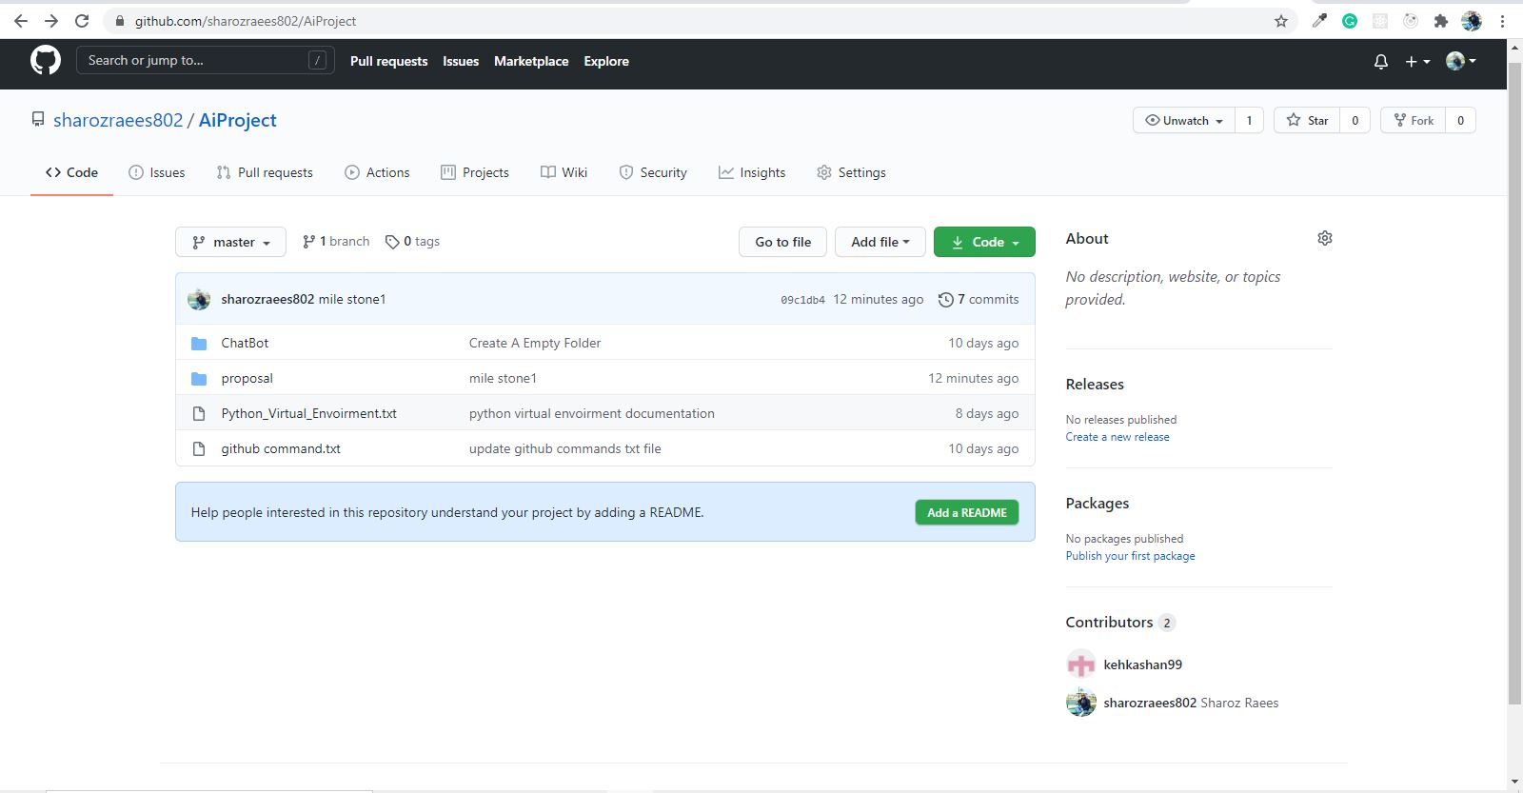

* 1. Software Requirements
* Version Control Git and GitHub
* Visual Studio Code
* Jupyter Notebook
* Mongo Db atlas

2.0. Project Planning

**2.1. Expected Result:** our project will be complete in 9th week

**2.2. Code Language:**

We will use Python, Flask, MongoDB, Rapid API, Dialog Flow API

**2.3. GitHub Link:** <https://github.com/sharozraees802/AiProject.git>

|  |  |  |  |  |  |  |  |  |  |
| --- | --- | --- | --- | --- | --- | --- | --- | --- | --- |
|  | Week1 | Week2 | Week3 | Week4 | Week5 | Week6 | Week7 | Week8 | Week9 |
| Google Dialogflow  & NLU |  |  |  |  |  |  |  |  |  |
| Flask/python,  API,  MongoDB |  |  |  |  |  |  |  |  |  |
| Testing &  Deployment |  |  |  |  |  |  |  |  |  |

**2.4. Project Planning:**

|  |  |  |  |  |  |  |  |  |  |
| --- | --- | --- | --- | --- | --- | --- | --- | --- | --- |
|  | Week1 | Week2 | Week3 | Week4 | Week5 | Week6 | Week7 | Week8 | Week9 |
| Google,  dialogflow,  NLU | ✓ | ✓ | ✓ |  |  |  |  |  |  |
| Flask/Python,  API,  Mongo DB |  |  |  | ✓ | ✓ | ✓ |  |  |  |
| Testing & Deployment |  |  |  |  |  |  | ✓ | ✓ | ✓ |

**3.0. Progress Table:**

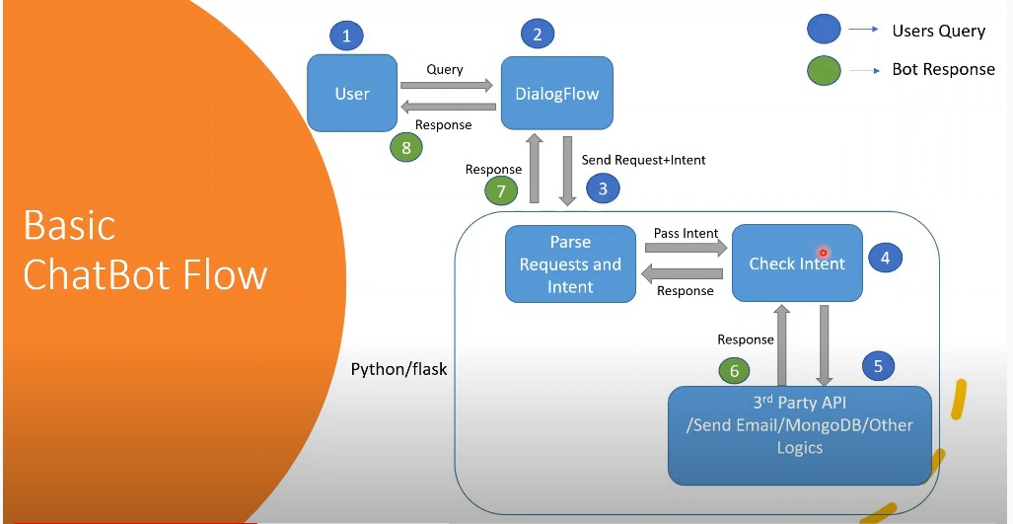**4.0. Basic ChatBot Flow:**

**5.0. DialogFlow:**

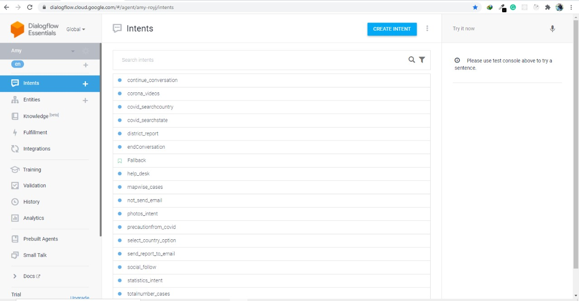5.1. Intents:

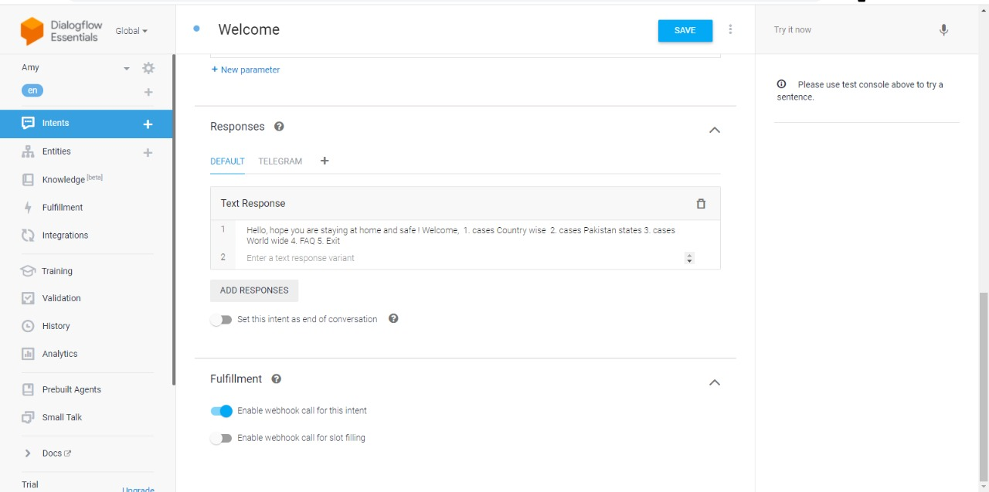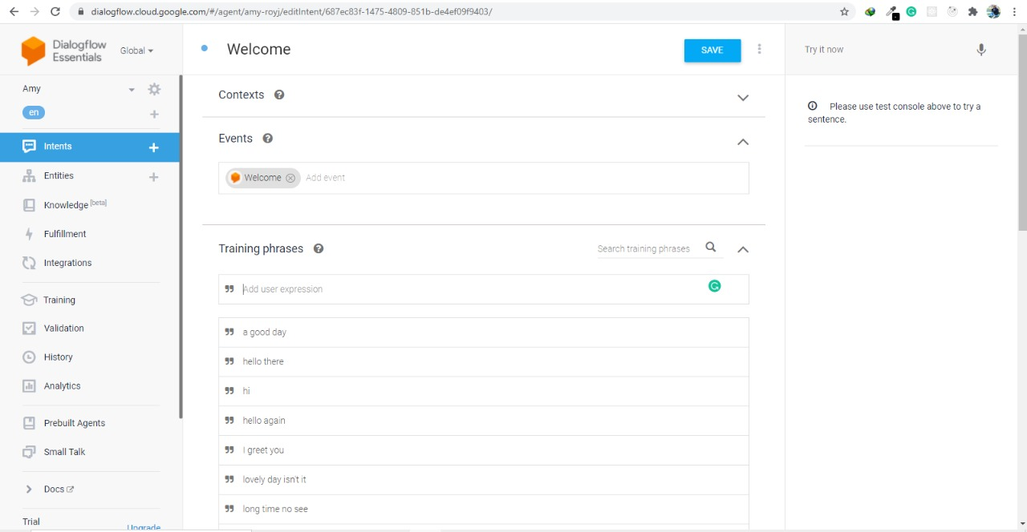5.1.1. welcome Intent:

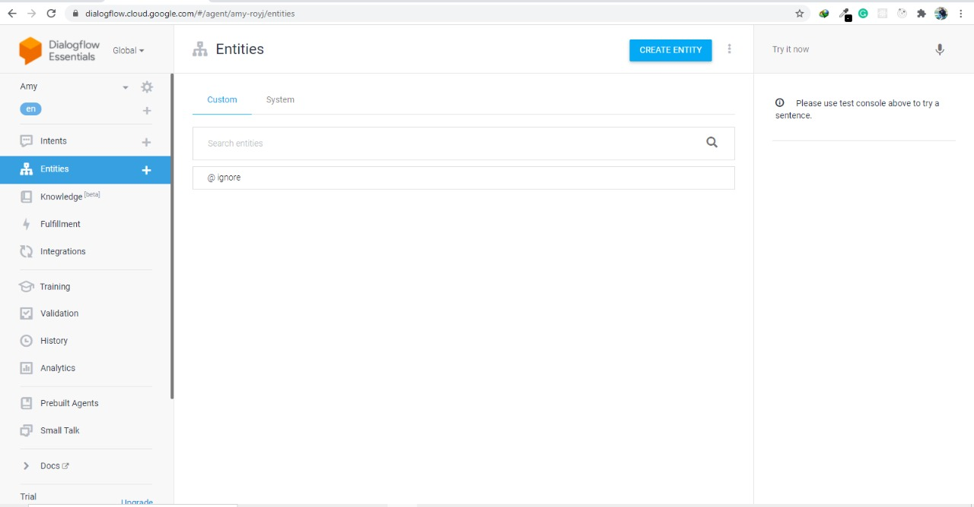5.2. Entities:

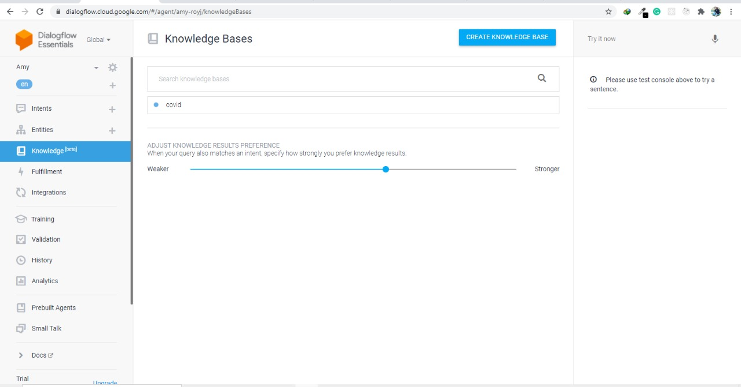5.3. Knowledge Base:

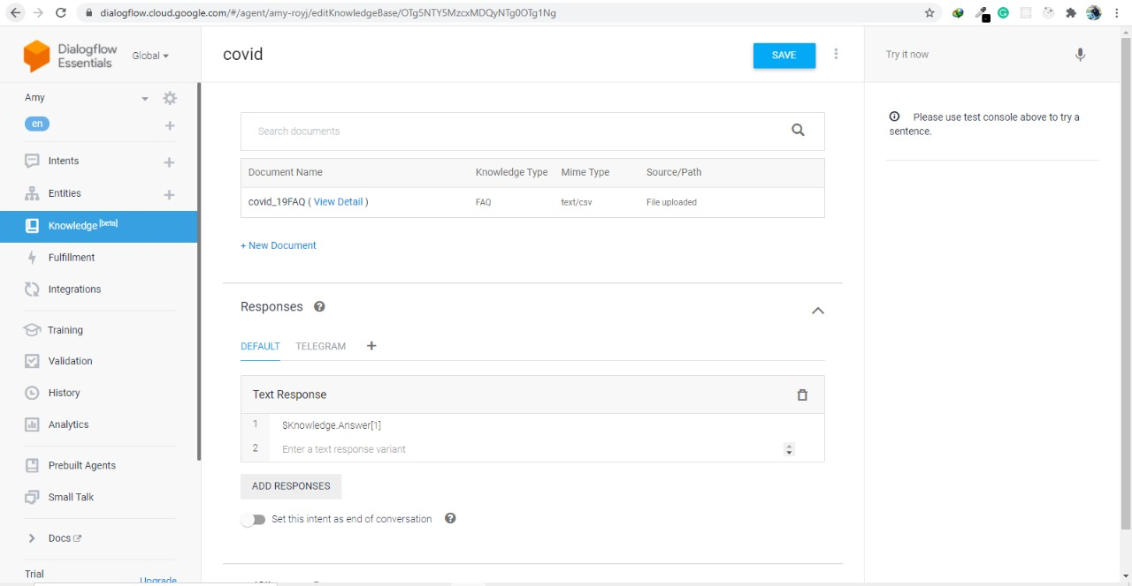5.4. Covid_19 FAQs:

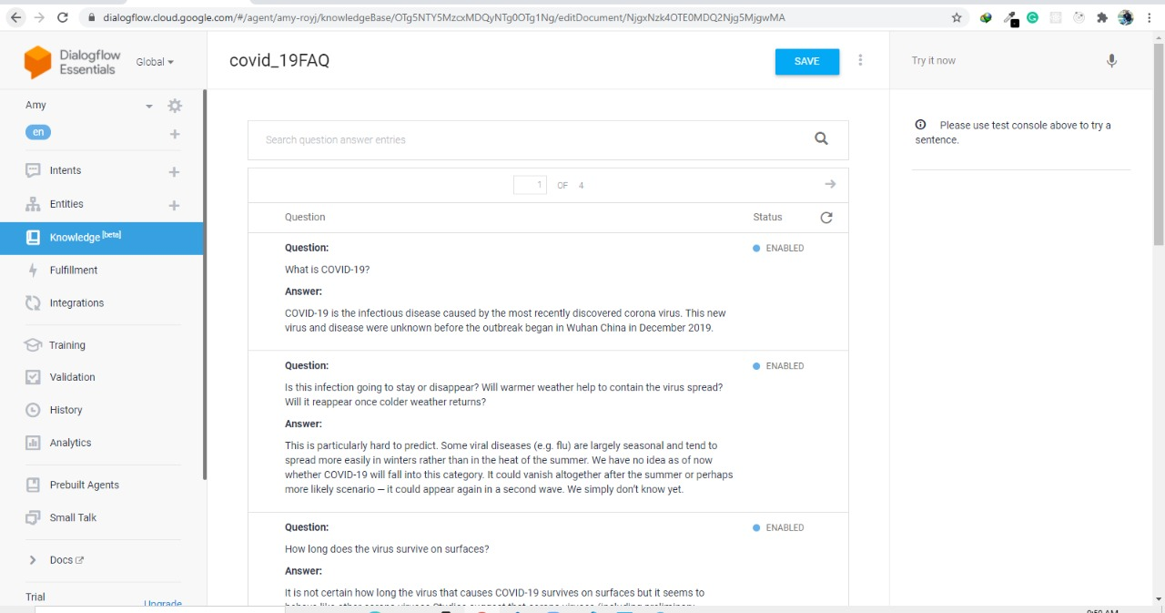

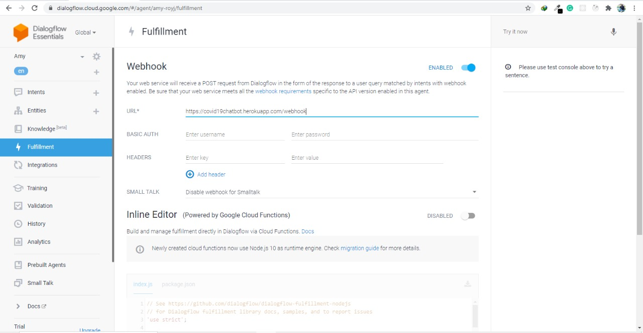5.5. Fulfilment:

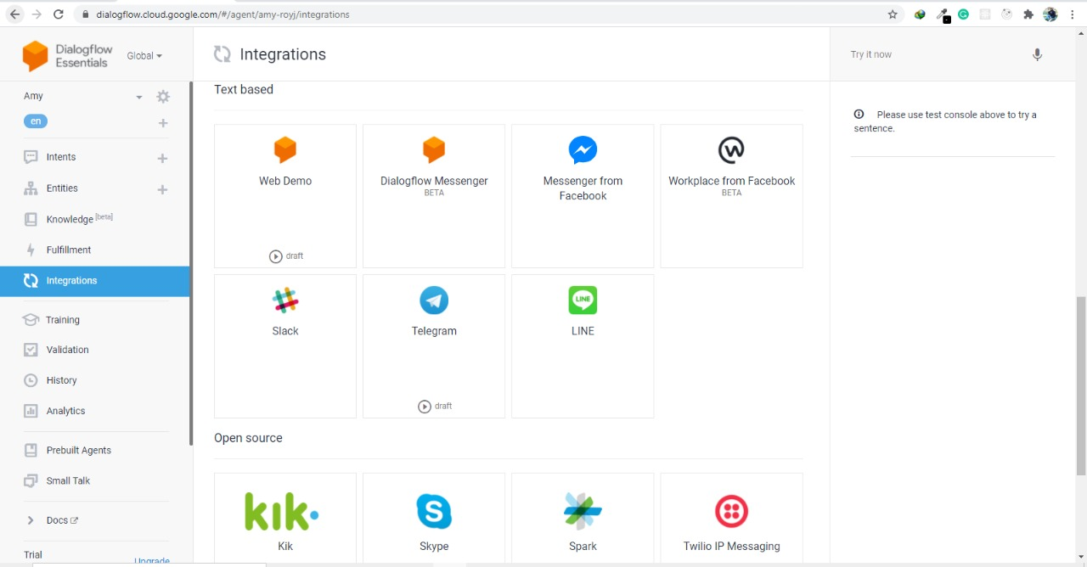5.6. Integration:

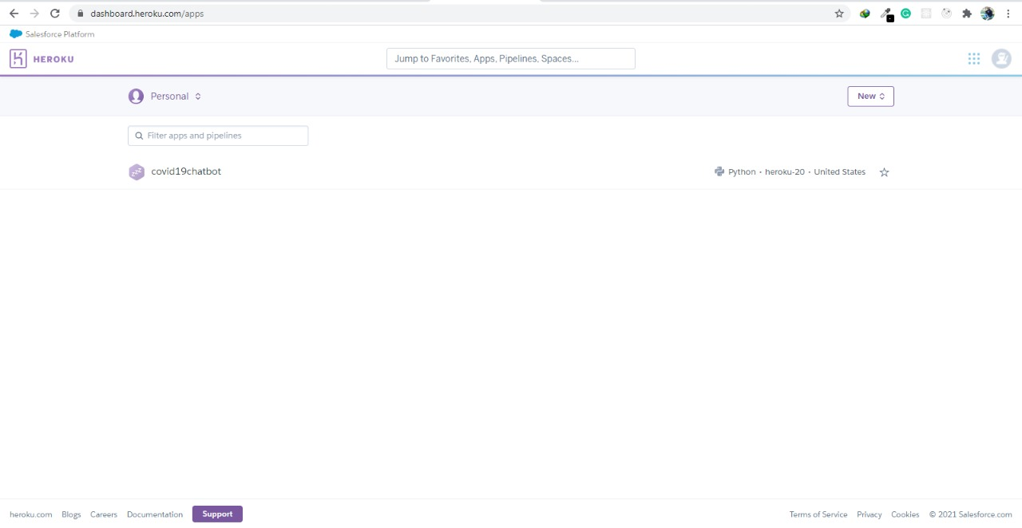**6.0. Heroku:**

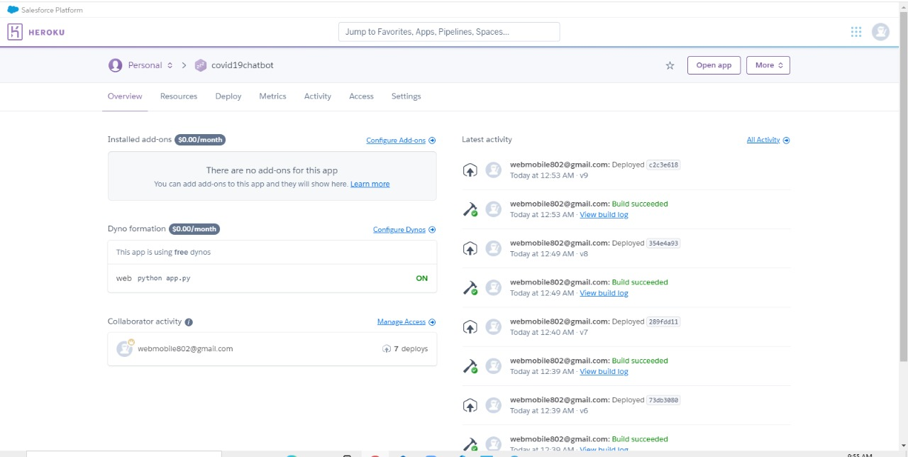6.1. Deployment log:

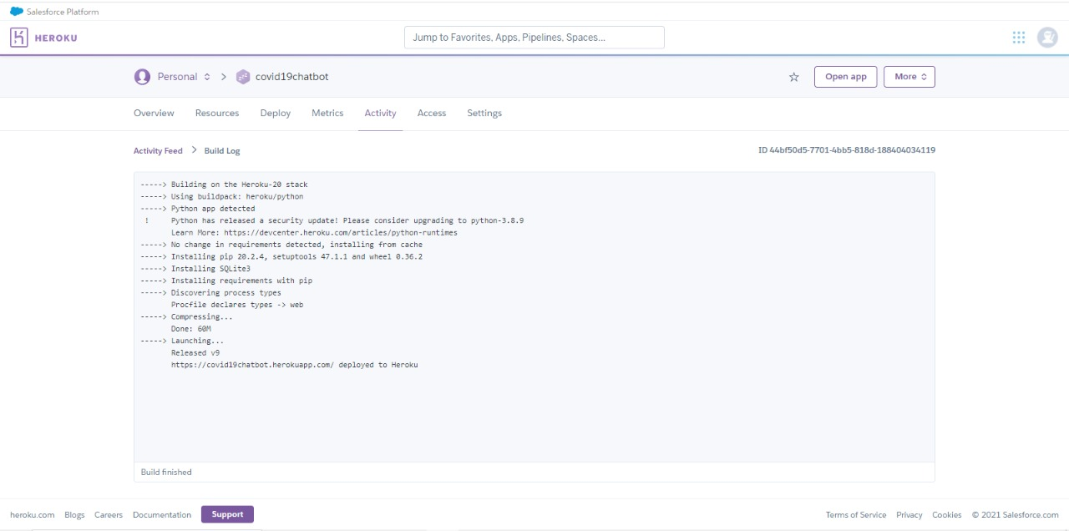6.2. Build Log:

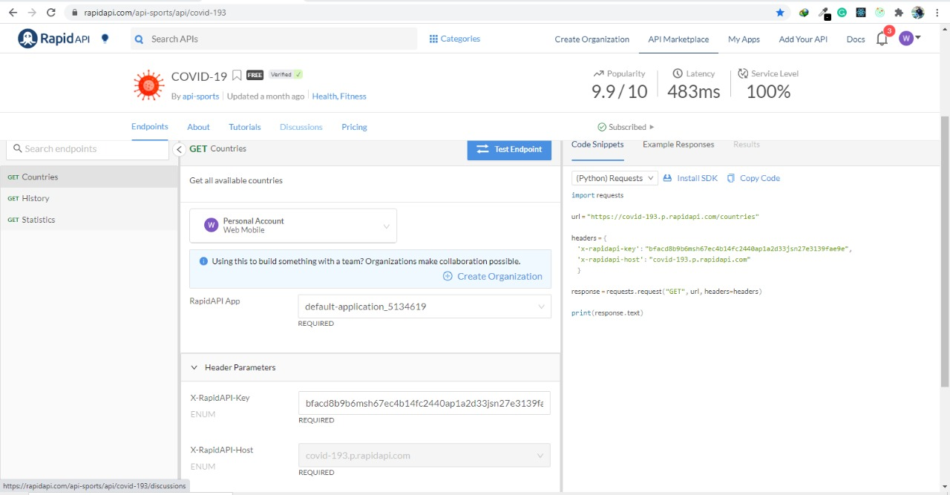**7.0. Rapid API:**

**8.0. MongoDB:**

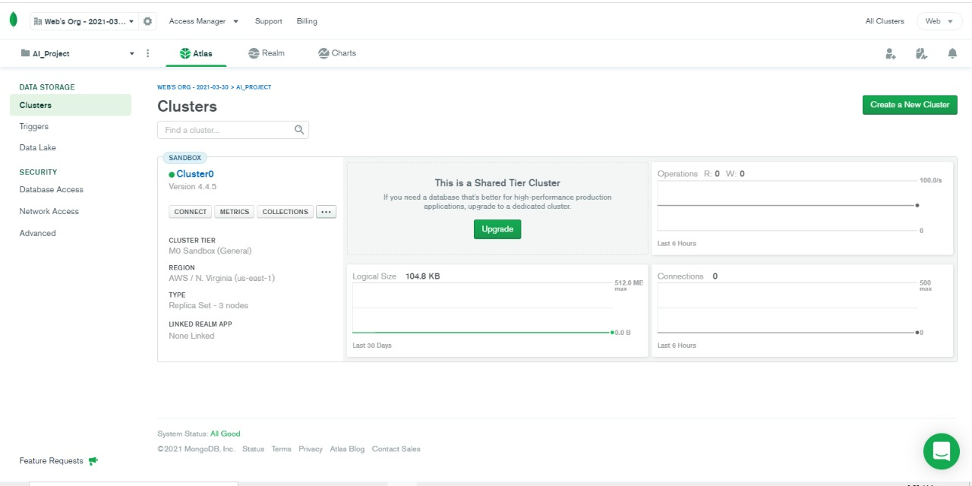8.1. Cluster:

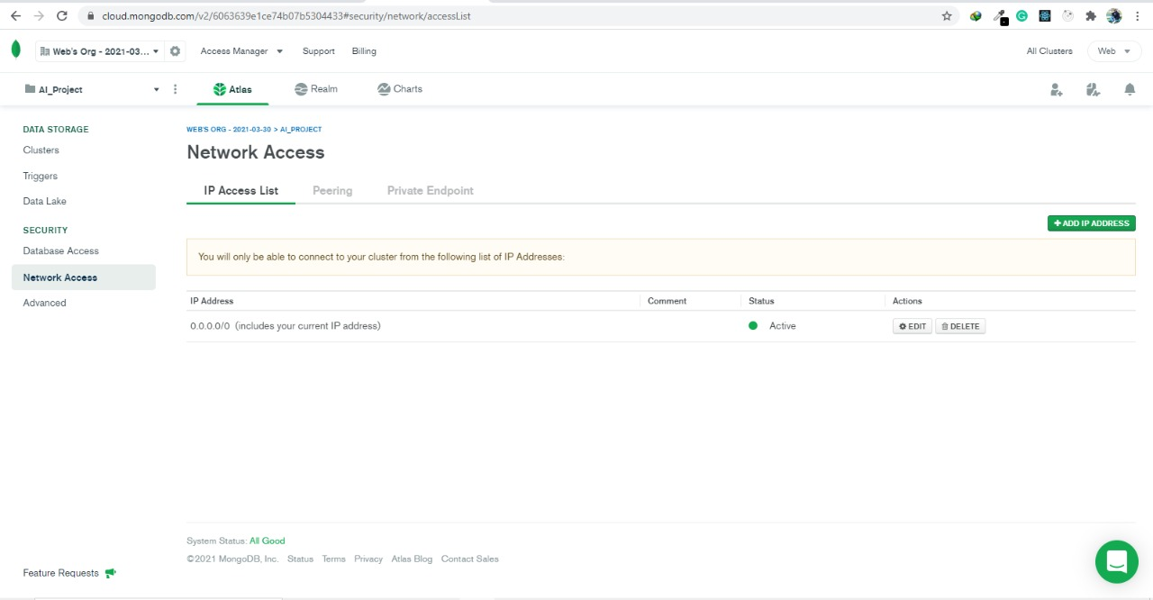8.2. Network Access:

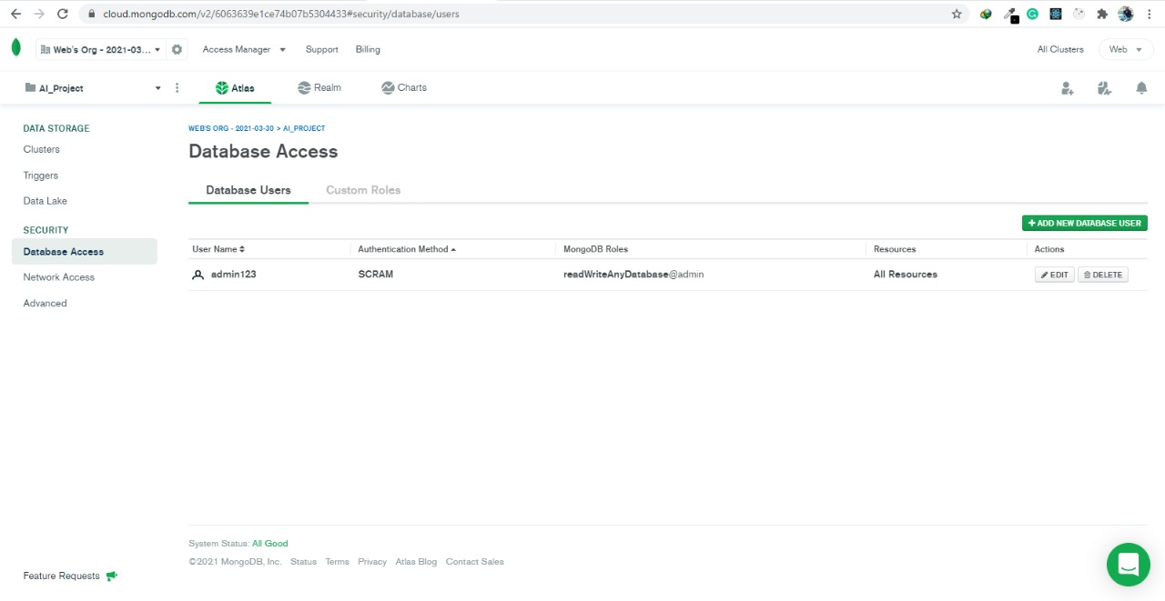8.3. Database Access:

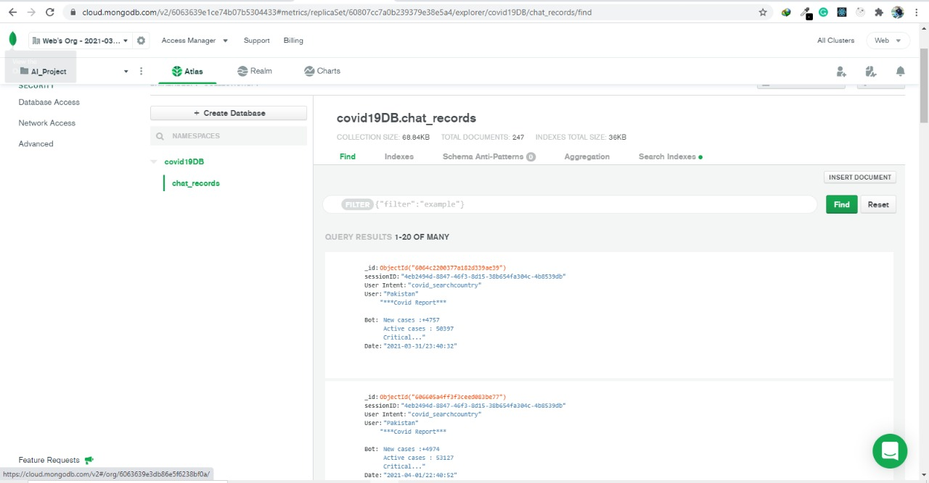**8.4. Covid 19 chat record collection:**

**9.0. Git Hub:**

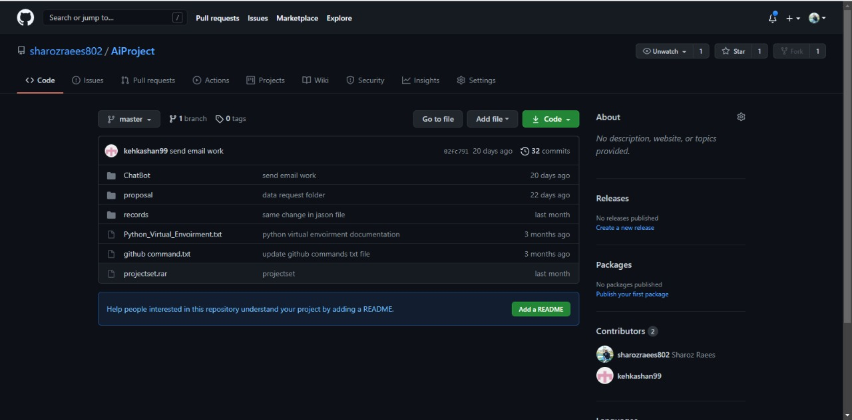9.1. Repository:

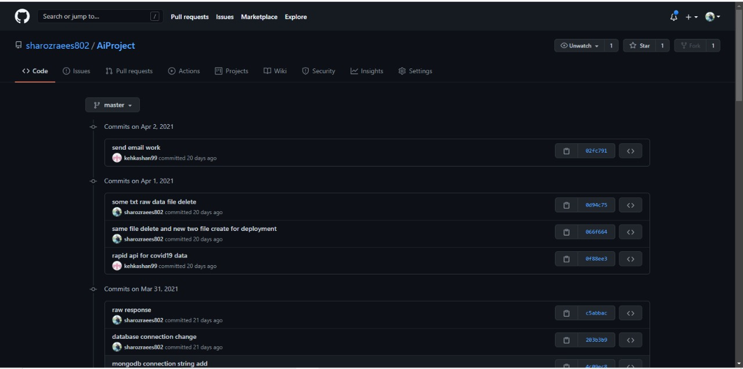9.2. Commit Log:

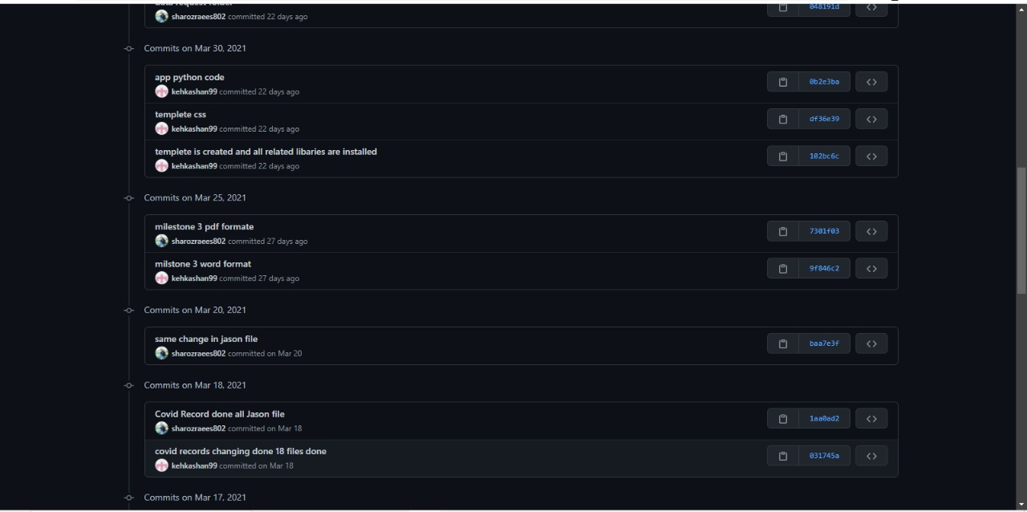

**10.0. Code:**

10.1. Code file directory:

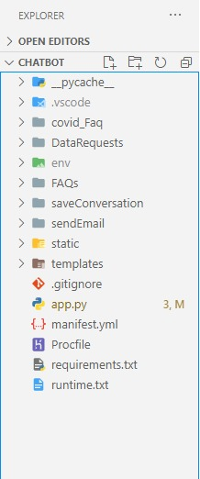

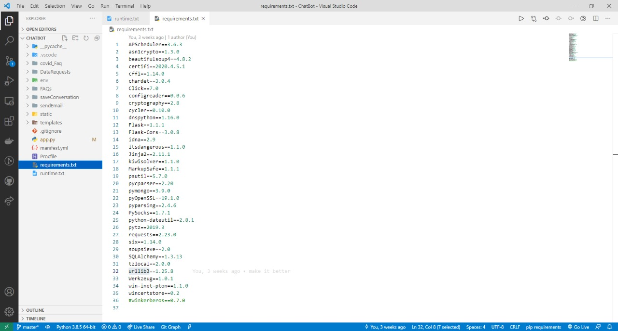**10.2. Requriment:**

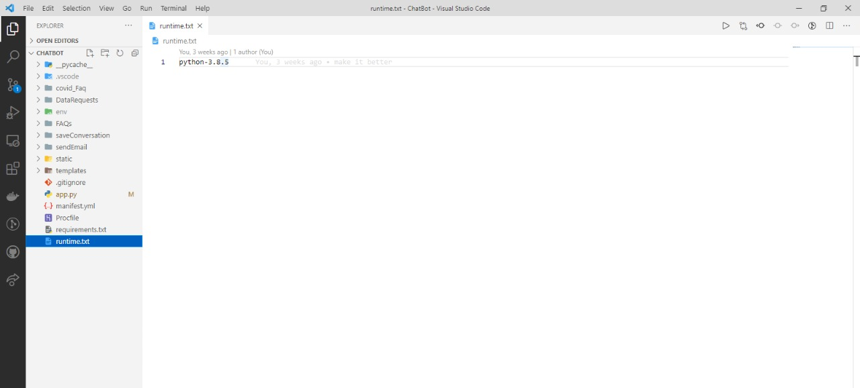10.3. Runtime:

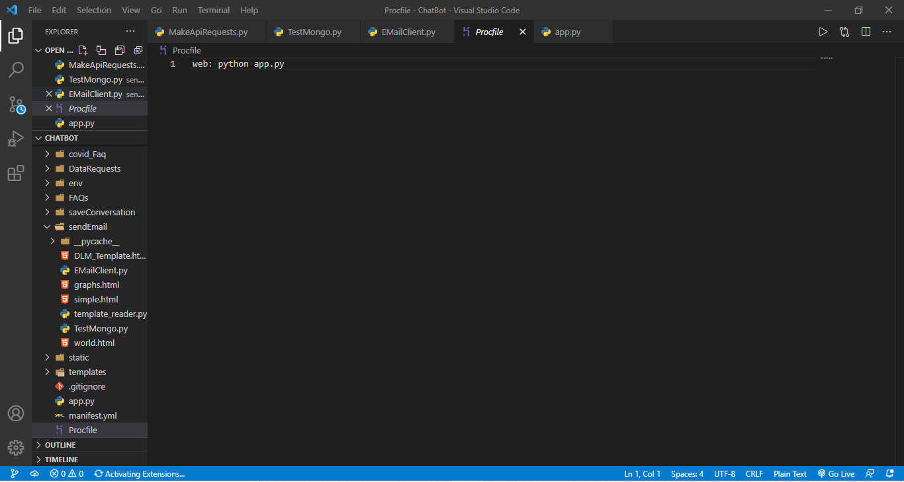10.4. Procfile:

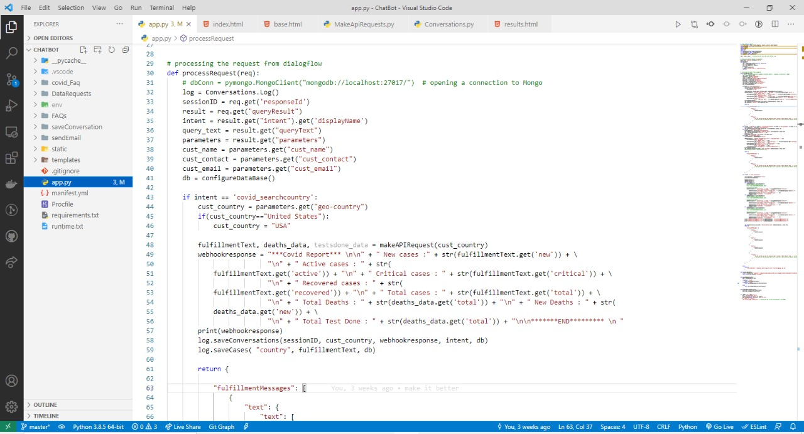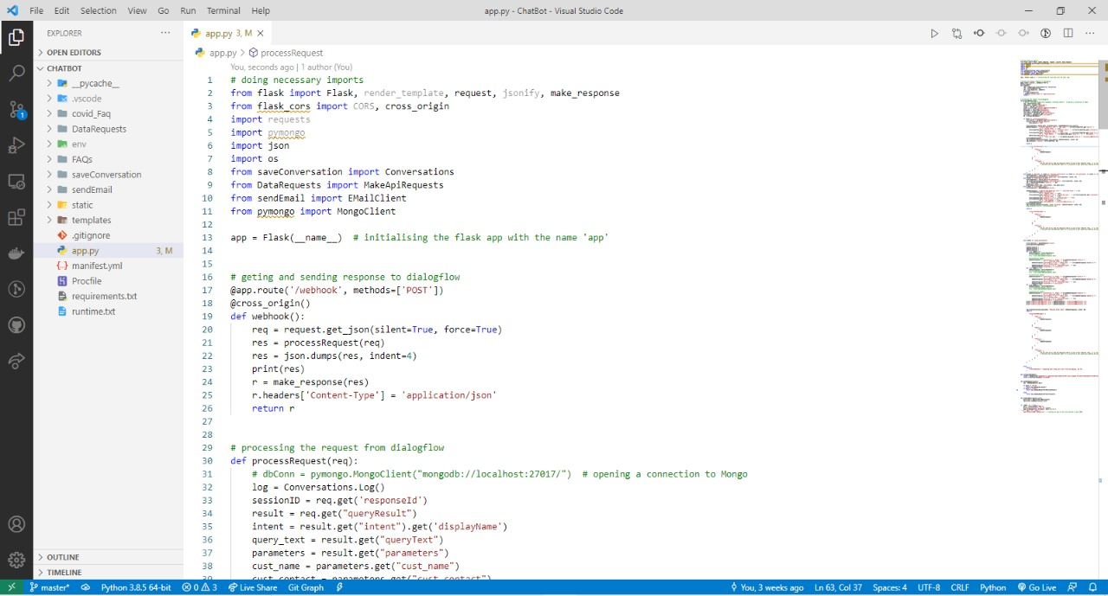10.5. App.py:

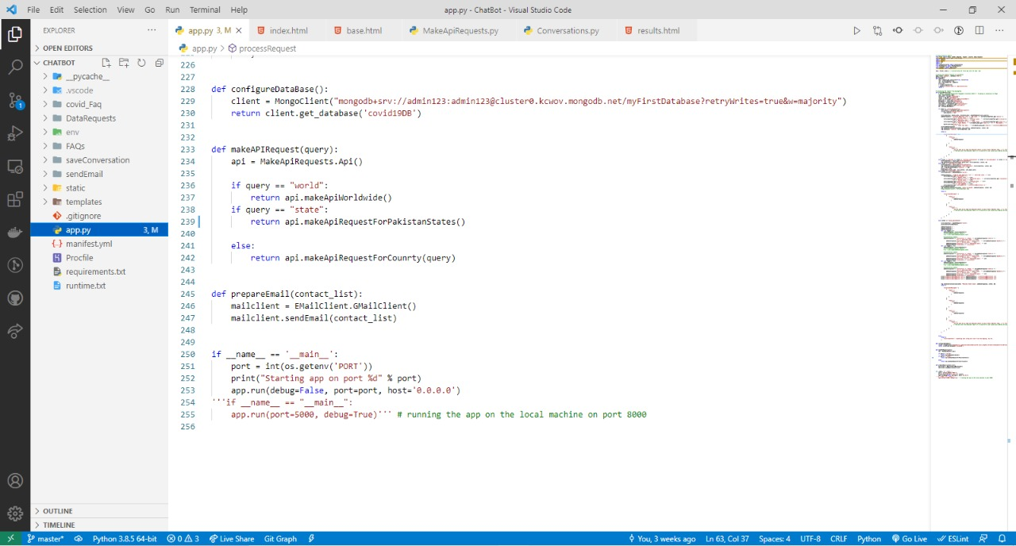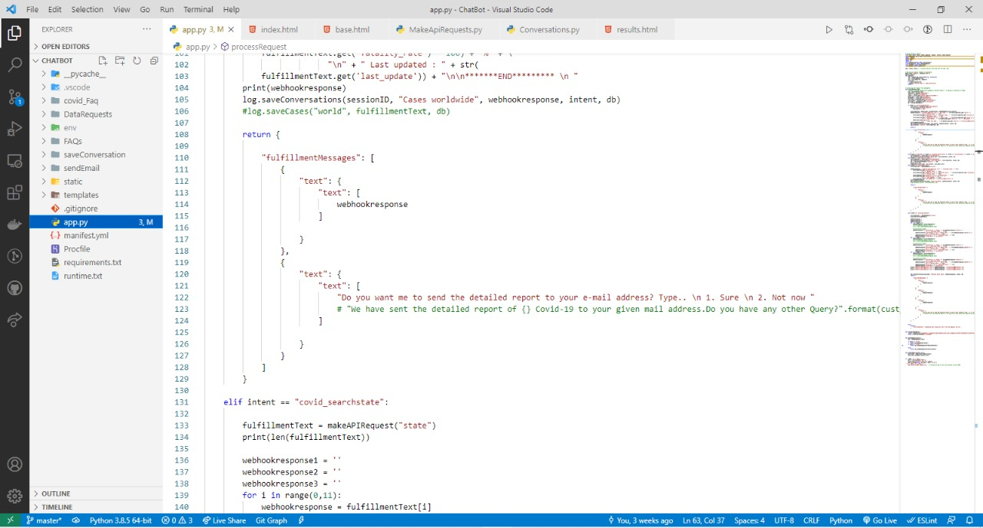

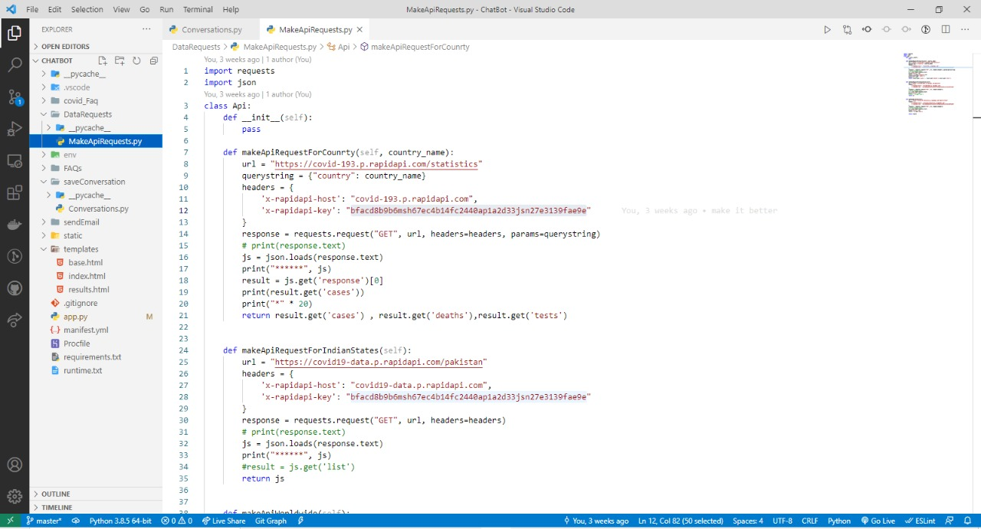**10.6. Make API Request:**

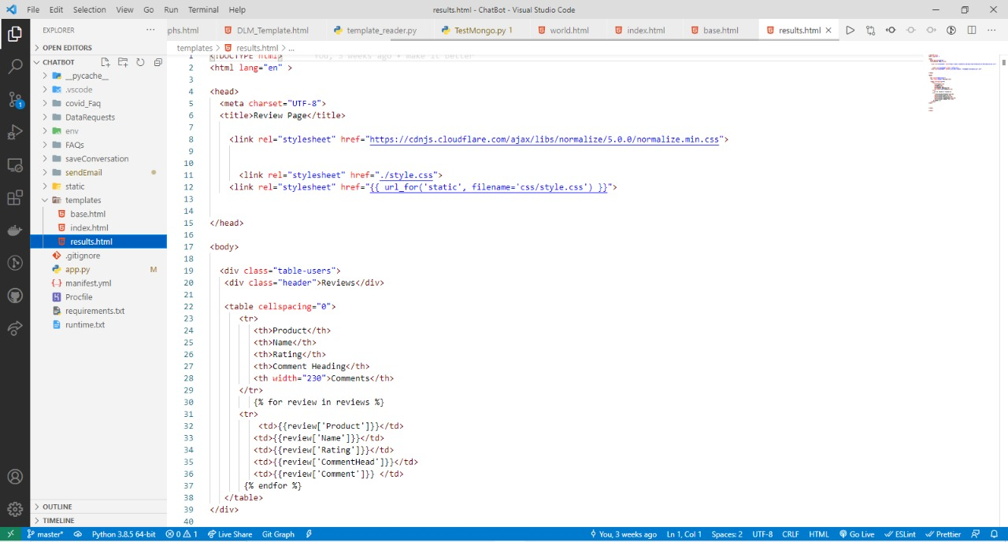10.7. Result:

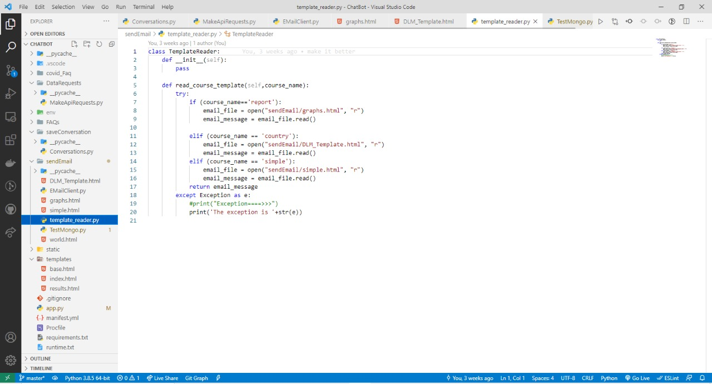10.8. Template Reader:

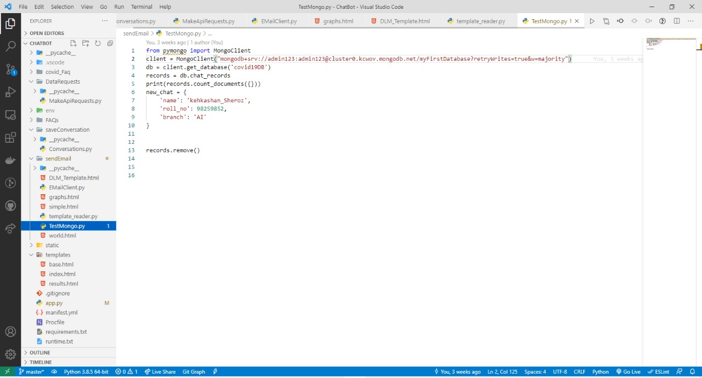10.9. Test Mongo:

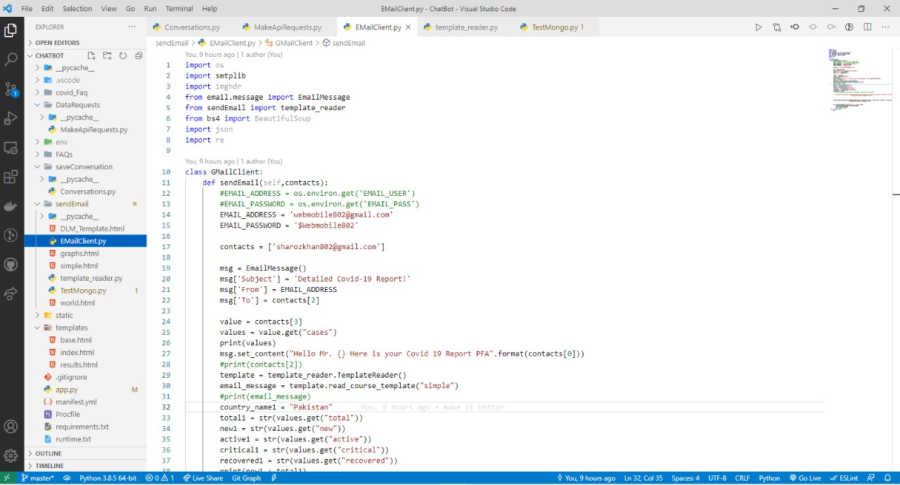10.10. Email:

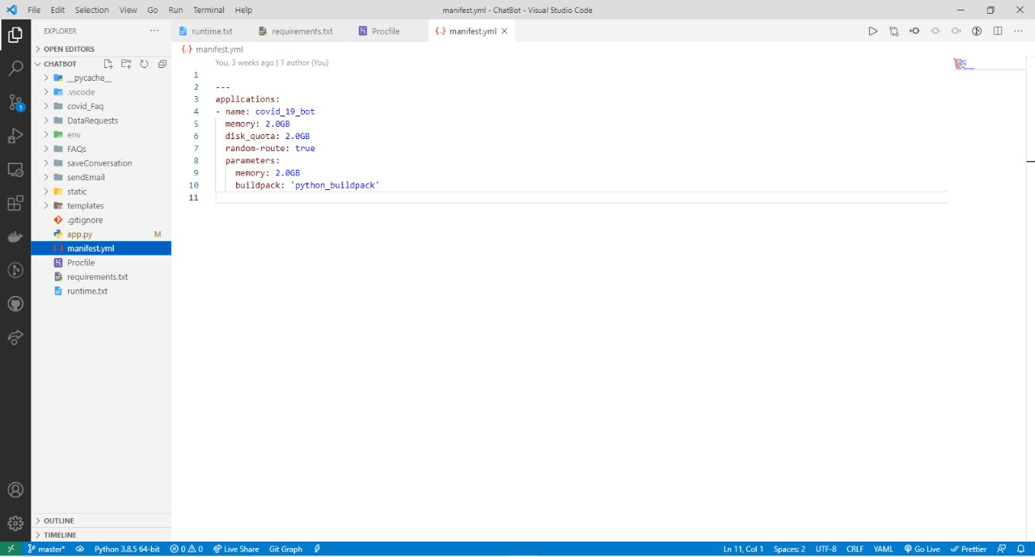10.11. Mainfest:

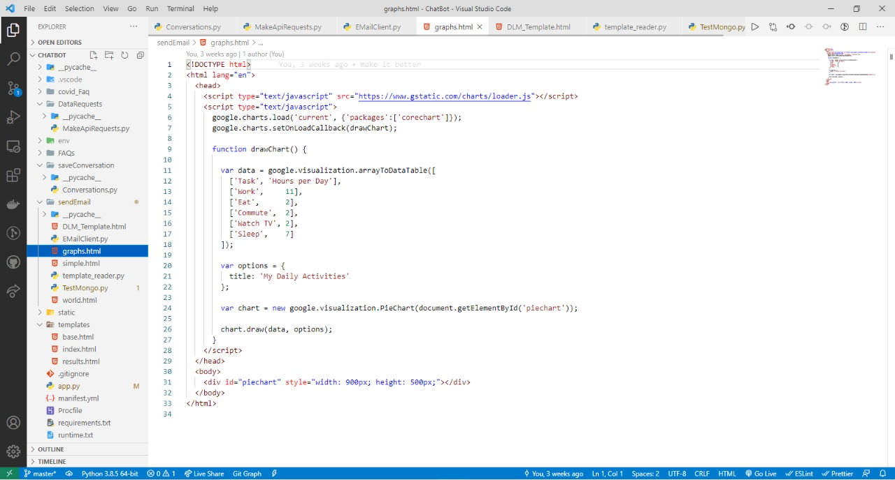10.12. Graphs:

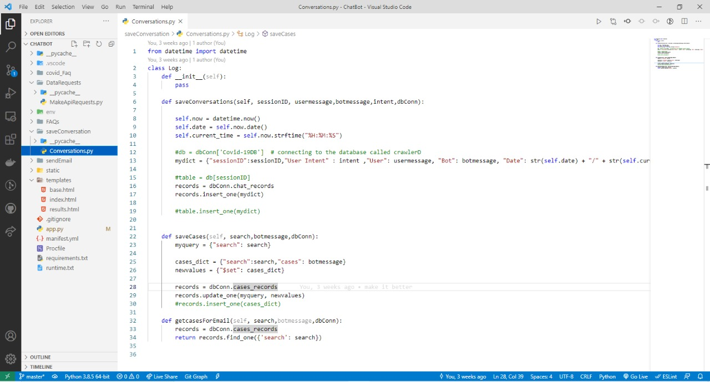10.13. Conversation:

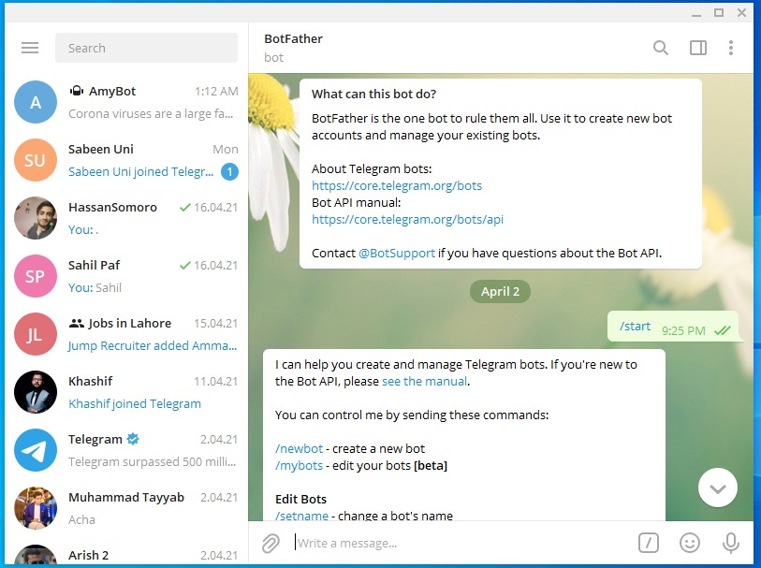**11.0. Creating Chatbot:**

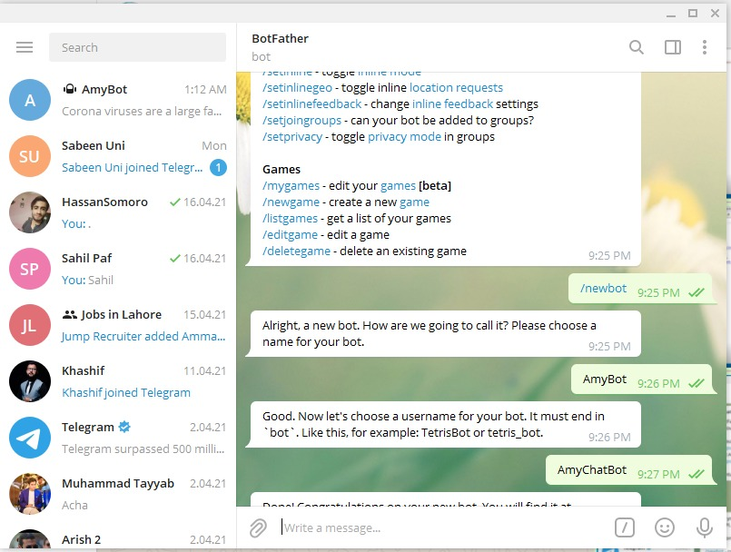

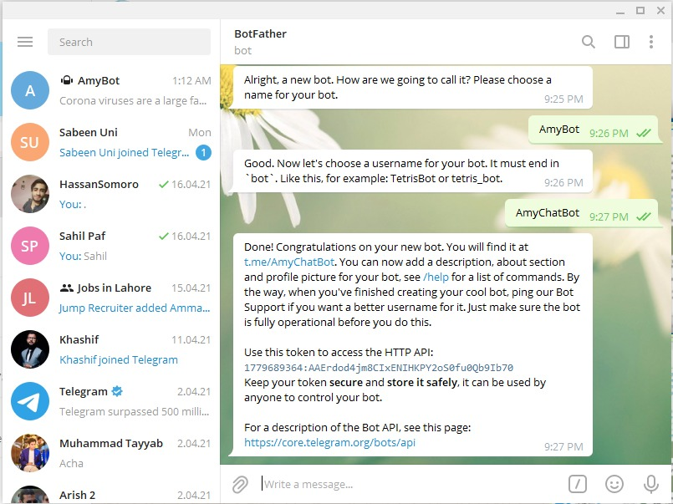

**12.0. Output of our project:**

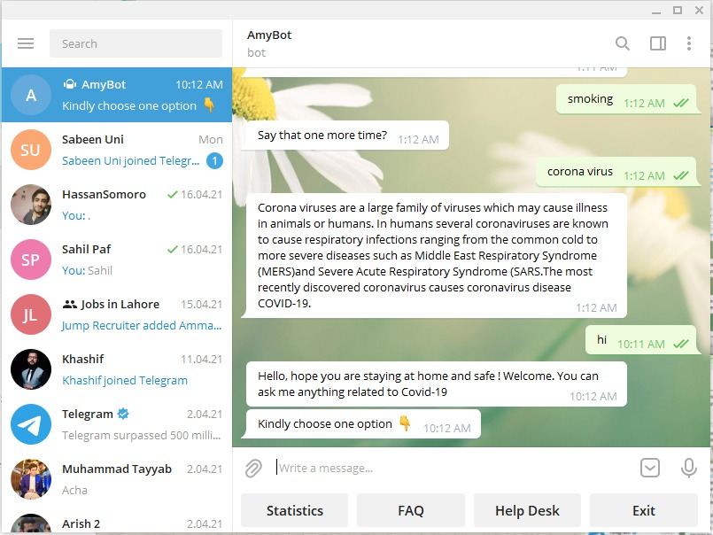

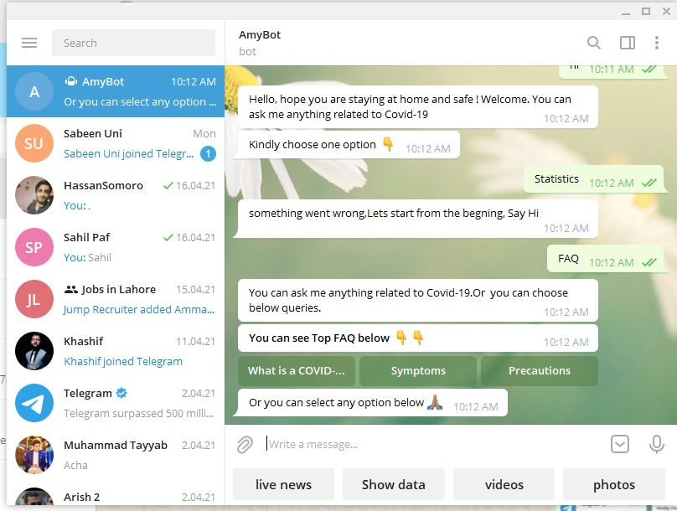

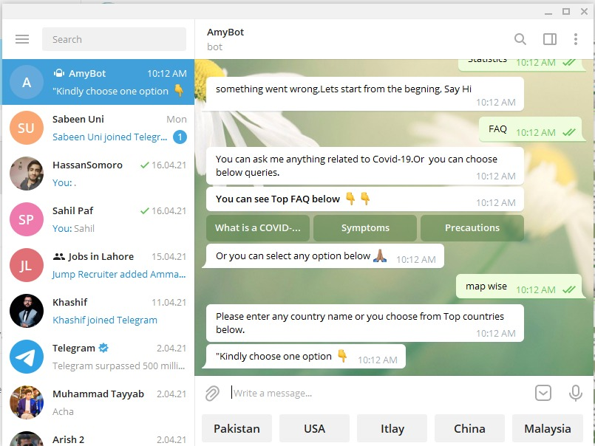

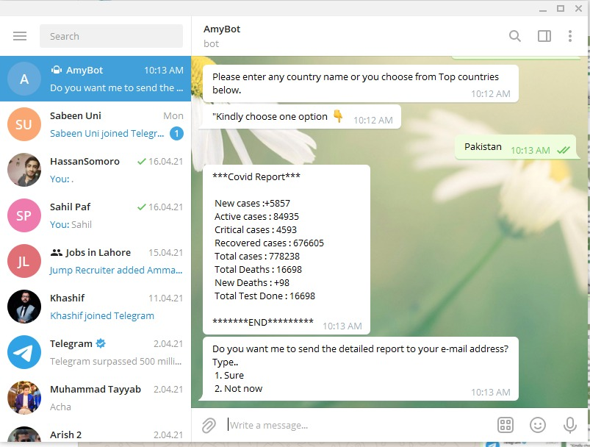

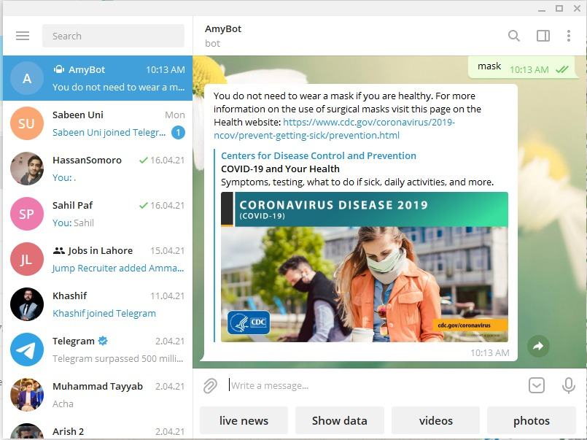

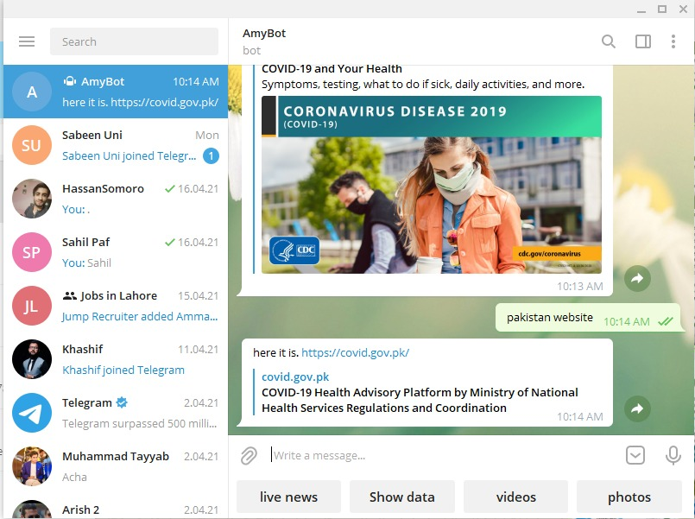

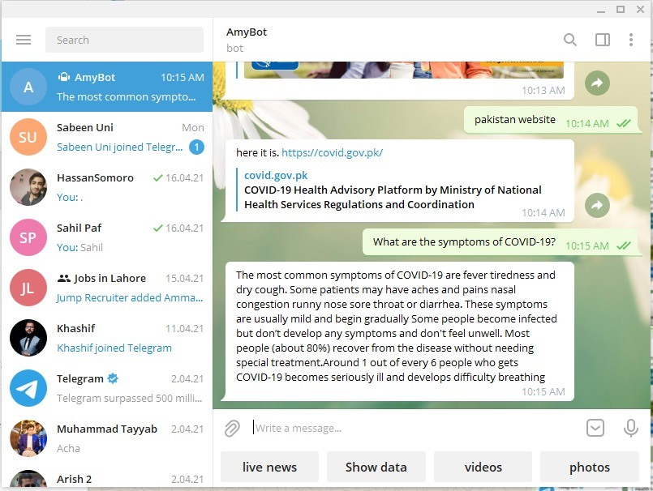

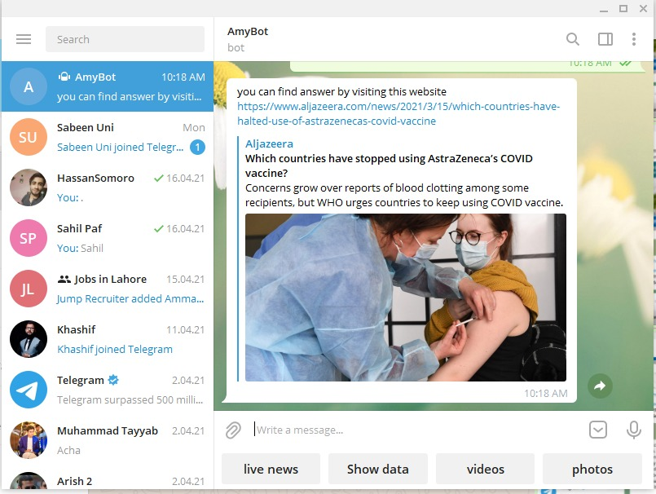

1. **Conclusion:**

We are all together in a fight against the COVID-19 pandemic. Chatbots, if effectively designed and deployed, could help us by sharing up-to-date information quickly, encouraging desired health impacting behaviours, and lessening the psychological damage caused by fear and isolation. Despite this potential, the risk of amplifying misinformation and the lack of prior effectiveness research is cause for concern. Immediate collaborations between healthcare workers, companies, academics and governments are merited and may aid future pandemic preparedness efforts

Date: 22 April 2021